## MUAC (Mid-Upper Arm Circumference) indicator and climate data: correlations

* Gifs of MUAC against precipitation and its lags
* Each image of gif presents one lag
* Correlation dies out with increasing lag
* ASAL counties, 2013-2017, monthly data
* MUAC from the NDMA bulletins



* According to correlation coefficients, MUAC and precipitation highly correlated
* Also MUAC and the lags of precipitation highly correlated

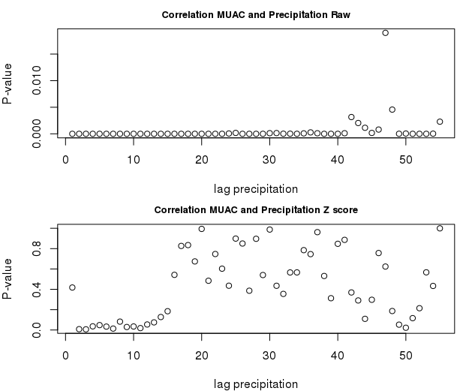

* For the raw precipitation (the upper picture above) , the correlations highly significant for all lags except one
  + This could be due to the county specific effects
* The p- values relatively higher for lag 40 and more
* For the Z score of precipitation, the correlation stops being significant for lags around 10 and more
* **Coping Strategy Index (CSI)- interesting point:** the correlation between CSI and z score of precipitation only starts to be significant at lag 4 of the precipitation.
  + Hence, the coping strategies are only significant after 3 months of drought (in terms of z-score of precipitation)

## Mixed effects models

#### 

#### The best specifications:

* Without weights:

$M_{i,t}=α+α_{i}+β^{P1}P_{i,t-1}+β^{P2}P_{i,t-2}{+β}^{P3}P_{i,t-3}+β^{P4}P_{i,t-4}+β^{P5}P_{i,t-5}+β^{P6}P_{i,t-6}+...$

$...+β^{T6}T_{i,t-6}+b_{i,t-4}^{P4}P_{i,t-4}+b_{i,t-5}^{P5}P_{i,t-5}+b_{i,t-5}^{P6}P_{i,t-6}+u_{i,t}$

* With weights (harvested area):

$M_{i,t}=α+α_{t}+β^{P1}P_{i,t-1}+β^{P2}P_{i,t-2}+β^{P5}P_{it-5}+β^{P6}P_{it-6}+β^{T5}T_{i,t-5}+...$

$...+b_{i,t-4}^{P4}P_{i,t-4}+b_{i,t-5}^{P5}P_{i,t-5}+b_{i,t-6}^{P6}P_{i,t-6}+b_{i,t-1}^{T1}T_{i,t-1}+b_{i,t-5}^{T5}T_{i,t-5}+b_{i,t-6}^{T6}T_{i,t-6}+u_{i,t}$

i...County

t...Month

Mi,t… % of children under 5 with Mid-Upper arm circumference (MUAC) < 135mm

𝛂… Intercepts

Pi,t...Z-score of precipitation (median) in county i, month t

Ti,t...Z-score of temperature (median), in county i, month t

𝛃...Slopes - fix effects

b...Slopes - random effects

* The specifications chosen from a number of models with various combinations of lags of precipitation and temperature
  + Max considered lags: 6
  + Min considered lag: 0 (current month)
  + Criteria of selection:
    - Significance of p-values of the independent variables
    - Results of an automatic stepwise selection considered
    - Value of the REML criterion

|  |  |  |
| --- | --- | --- |
| **Fixed effects** | **No weights** | **Weights = harvested area** |
| Precipitation z-score, median, lag 1 | -0.743*** | -0.531*** |
| Precipitation z-score, median, lag 2 | -0.603*** | -0.580*** |
| Precipitation z-score, median, lag 3 | -0.373* | --- |
| Precipitation z-score, median, lag 4 | -0.571* | --- |
| Precipitation z-score, median, lag 5 | -0.847** | -1.022*** |
| Precipitation z-score, median, lag 6 | -1.047*** | -0.914*** |
| Temperature z-score, median, lag 5 | --- | -0.751*** |
| Temperature z-score, median, lag 6 | -0.342** | --- |

#### Diagnostic plots:

